Results summary
I used a different standard curve for each bioassay because there were much better regressions individually than when I combined them into one standard curve.
Generally, the raw data met assumptions regarding normality (with just a few exceptions) and homogeneity of variances. When separated by whether nutrients were added, residuals mostly met those assumptions as well (with the exception of carbamazepine and PFOS without nutrients that didn’t quite meet the normality assumption). When combined, residuals more frequently defied assumptions. I would assume this is because biomass was generally higher in the nutrient amended groups and that can skew things, but should I try a transformation or something else?

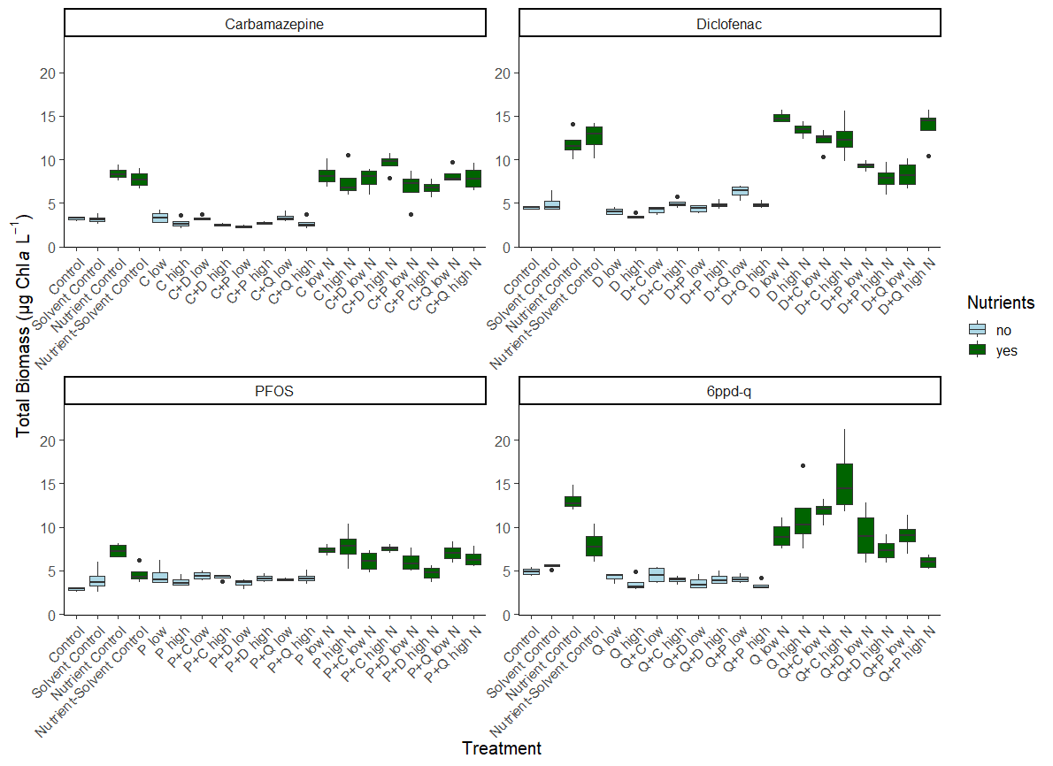
One-way ANOVAS
One-way ANOVAs with non-nutrient-amended and nutrient amended groups separated (i.e. for the carbamazepine bioassay there were two one-way ANOVAs: one for treatments without added nutrients and one for groups with nutrients) suggested that there were significant differences for carbamazepine without nutrients, diclofenac with and without nutrients, PFOS without nutrients, and 6ppd-q with and without nutrients:
Group | df | F | p
Carb w/o nutrients | 9 | 2.948 | 0.0124
Carb w/ nutrients | 9 | 1.428 | 0.221
Dic w/o nutrients | 9 | 7.386 | 1.35x10⁻⁵
Dic w/ nutrients | 9 | 8.993 | 1.98x10⁻⁶
PFOS w/o nutrients | 9 | 1.653 | 0.145
PFOS w/ nutrients | 9 | 4.069 | 0.00171
6ppd-q w/o nutrients | 9 | 4.171 | 0.00144
6ppd-q w/ nutrients | 9 | 5.531 | 0.00017

Even though the carbamazepine bioassay without added nutrients had significant differences, the Tukey post-hoc test did not find significant differences between groups. For diclofenac without nutrients, a Tukey test indicated significant differences between D+Q low and every other group, including the control (p = 0.0014757) and solvent control (p = 0,0449052). Biomass in the D+Q low group was higher than every other group. For diclofenac with added nutrients, Tukey tests indicated many differences between groups. Generally, D+P low, D+P high, and D+Q low had lower biomass than other treatment groups, though the only significant difference between a treatment and the controls was with the D+P high group that had lower biomass than both the control (p = 0.0388413) and solvent control (p = 0.0072046). In the nutrient amended PFOS bioassay, two groups had significantly greater biomass than the solvent control: P low (p = 0.0474300) and P+C high (p = 0.0305383). However, these groups were not different from the control. Additionally, P+D high was significantly lower than P high (p = 0.0149015) and P+C high (p = 0.0357582). In the non-nutrient amended 6ppd-q bioassay, several groups had significantly lower biomass than the solvent control: Q+C high (p = 0.0530863), Q+D low (p = 0.0078596), and Q+P high (p = 0.0016971). The Q+P high group was also significantly greater than the control (p = 0.0484354). In the nutrient amended bioassay, Q+C low and Q+C high had greater biomass than many groups, and Q+P high had significantly lower biomass than the control (p = 0.0083987) but was not different from the solvent control.
Two-way ANOVAs
For the carbamazepine bioassay a two-way ANOVA indicated that nutrients had a significant impact on biomass (df = 1, F = 457.149, p < 2.0x10⁻¹⁶) while treatment did not (df = 9, F = 1.903, p = 0.686). There was no significant interaction. For the other three bioassays there was a significant interaction between nutrient amendment and treatment (diclofenac: df = 9, F = 11.598, p = 2.64x10⁻¹⁰; PFOS: df = 9, F = 3.762, p = 0.000839; 6ppd-q: df = 9, F = 5.117, p = 3.89x10⁻⁵).

To me this suggests a few things. First, carbamazepine does not have much impact on biomass OR they weren’t properly dosed (anecdotally, carbamazepine sticks to plastic really well so our samples may not have been properly exposed). Second, nutrient availability is an important component of the response to contaminants. For three of the four bioassays, there was a significant interaction between nutrient addition and treatment. Further, groups responded differently relative to each other in the presence of nutrients. For example, in the diclofenac bioassay, D+Q low without nutrients had the highest biomass of all groups, but D+Q low in the nutrient amended condition had lower biomass compared to most other groups. We also saw a different range of biomass in the nutrient amended groups compared to the non-nutrient amended groups, particularly in the diclofenac and 6ppd-q bioassays. Even though there were statistically significant differences in biomass between non-nutrient amended treatments, those differences were typically around 1-2 µg l⁻¹ and never greater than 3 µg l⁻¹, whereas those differences were amplified in nutrient amended groups.

My thoughts for the ASLO talk: try to sell this as a more accessible method to investigate these kinds of questions with more replicates and more time points, emphasize the importance of nutrients
My thoughts for future experiments: forget carbamazepine, focus on diclofenac and either 6ppd-q or PFOS. All three would be interesting, but less manageable. Could be interesting to compare from a nutrient impaired and nutrient limited water body. Or incorporate a range of nutrients and/or range of concentrations.
Next step: log-transform data to look at change over time for linear mixed model to understand if these changes happen over time.

